# Week 6 Lab ReadMe

Chenran Gong

In this lab, I established an ESB successfully by Apache ServiceMix.

## Installation and Start:

Apache ServiceMix was installed successfully. After inputting “./bin/servicemix” on the console, it showed below:

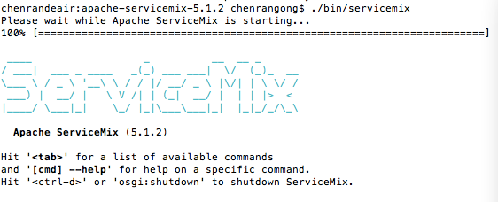

## Scenario 1:

### Check Bundles:

After inputting “osgi:list” on the console, it showed:

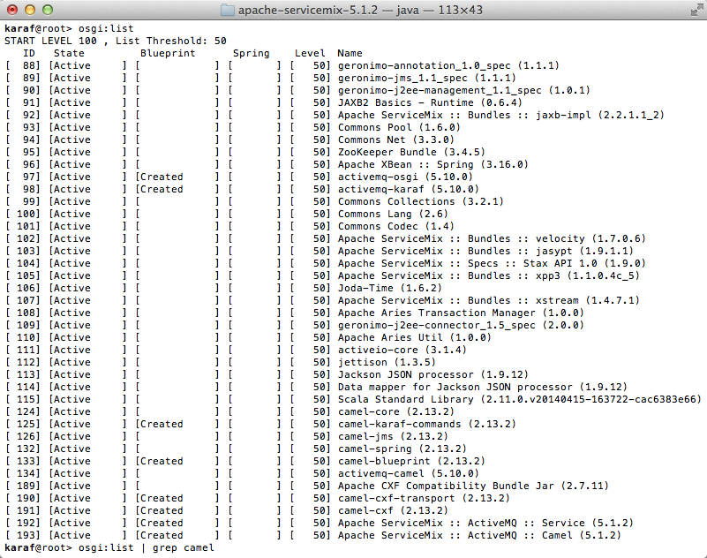

### Deploy a New Route on ServiceMix:

Put the createRoute.xml into the ServiceMis’s deploy directory. And put a test.xml in the camel/input directory. The test.xml will be put into the camel/output directory automatically.

The log shows below:



## Scenario 2:

Adding ActiveMQ to the Mix:

In this scenario, an event JMS message was sent onto a queue when moving files between directories. And a Camel route was created to receive the events and log them.

Put the MovingFileAndSendingEventMessages.xml into the ServiceMis’s deploy directory. And put a test.xml in the activemq/input directory. The test.xml will be put into the activemq/output directory automatically.

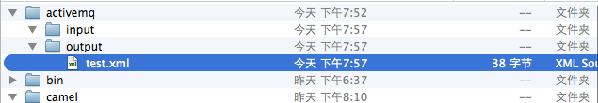

Put the ReceivingFileAndSendingEventMessages.xml into the ServiceMis’s deploy directory. And input log:display on the console. It shows:



## Think

(Requirement: Anything that you can enhance/add to an ESB?):

After searching and reading some papers, I learnt about that there are some limitations of today’s ESB framework, such as only syntactic description of service interface, inability to perform semantic mediation and cannot be able to process integration systems. Therefore, semantic description may be useful to enrich the semantics of data and services on ESB.